**Tajms Studios proudly presents!**

**a tajms opengl production**

**pacman 3d**

**Group Members:**Eric Ahlström  
John Bergsten  
Lucas Holmqvist  
Christian Markowicz  
Konrad Öhman

Contents

Introduction 2

Gameplay introduction 2

Architecture Diagram 3

Game-specific Subsystem 4

Front-end System 4

Gameplay Foundations 5

Visual Effects 5

Low-Level Renderer 5

Debugging 6

Collision and physics 6

Audio 6

Human Interface Device 6

Resources 7

Core Systems 7

3rd Party SDKs 7

OS and Platform 7

Domain Modell 8

Key Game Logic Concepts 9

Maps 9

Collision Detection 9

Graphics 10

Class Diagram 11

Game Logic Diagram 11

Work Breakdown Structure 12

References 13

# Introduction

Pacman is one of those ironical video games produced during the industry’s infancy. No one calls him/herself a gamer without having at least heard of the legend that is Pacman. We are thrilled to now be tasked with the creation of our own version. This document is the basic conceptual outlines of what we hope our game will be.

# Gameplay introduction

The player plays as Pacman from a first-person perspective, albeit in a 3D environment. The goal, as with the classic Pacman-games, is to eat all the candy while avoid being eaten by the ghosts. One fundamental change is the layout of the map. The player has to navigate on paths surrounded by black pits which Pacman can fall down into and die.  
 Aside from the dangers of falling down from the paths, Pacman will starve if he fails to continually eat candy. This has consequences: Pacman’s movement speed will be reduced and the light will begin to fade, which will make spotting and running away from ghosts significantly harder.

# J:\Pacman\ArchitectureDiagram.pngArchitecture Diagram

## Game-specific Subsystem

This block contains components that are specific for this game, such as the candy and ghosts.

**Camera** contains two cameras: a noclip-camera to easily fly around the world for debug purposes and a first-person game-camera for the final gameplay.  
**AI** directs the ghosts’ movement by sending a path to each ghost. It also tells the ghost whether to flee from Pacman or to chase him.   
**Player mechanics** manages play-inputs from the keyboard and mouse which are then used to control Pacman and for navigation of menus.  
**Game-specific Rendering** renders the terrain and different objects.  
**Candy** aresmall pieces of candy which Pacman eats.  
**Ghosts** are the main enemy. They follow a path given by the AI, based on their state and Pacman’s position.   
**Buffs** changes the state of Pacman. The most basic buff is that he can eat the ghosts for a brief period of time.

## Front-end System

Contains HUD and GUI. These are things that don’t interact with the gameplay but rather shows info that is useful to the player and directs the player to different places of the program.

**HUD** (Heads Up Display) contains essential information such as lives and score which is then presented on the screen during gameplay.  
**GUI** (Graphical User Interface) includes different menus which navigates the player to different places in the program.

## Gameplay Foundations

This block contains map loading, different static objects (like spawn points) and an event/messaging system.

**Map Loading** reads the map and saves both a logical representation of the map for collision detection and path finding, and a graphical representation that is sent to the graphic interface.  
**Static World Elements** are elements/objects that are in the same place throughout the game, like spawn points.  
**Event/Messaging System** gives the player information about gameplay states, for example when the ghosts changes state from fleeing to chasing.

## Visual Effects

Different lighting and special effects.

**Point Light:** a light source emitting light from one point. It is the main source of light in our game.  
**Particle Effects** is a way to demonstrate small particles with different movement patterns. Explosions are represented by particle effects.  
**Reflections** put a texture on a surface that represents the view of the surface.  
**Environment Map** controls background textures.

## Low-Level Renderer

Contains lower levels of rendering, such as shaders.

**Shaders** are programs that reside in the GPU. They tell the GPU how to color each pixel seen by the camera.  
**Cameras** are matrices that convert the world into different views.  
**Text And Fonts** are outputs to the GUI and can also be used for debugging. The fonts tell the text how to display itself.  
**Textures/Surface Management** puts the correct texture on the right object.  
**Graphics Device Interface** is the interface towards the low-level renderer.

## Debugging

Is used to check the program code for bugs, glitches and performance issues.

**Performance and memory stats** keep stats about performance, such as frames per second.  
**Debug Drawing** prints the map and objects in different ways. Can be used for drawing only the outlines of polygons.

## Collision and physics

Used to check different forms of collisions.

**Physics / Collision World** use positions to check if collisions occur.

## Audio

Plays sounds and music depending on the position of Pacman.

**Audio Playback / Management** controls what sounds to play and what volume it should be played at. The volume depends on the distance from the audio source and Pacman.  
**3D Audio** makes the sound appear different in each output device.

## Human Interface Device

Mouse and keyboard are the only interface devices that the player can use.

**Physical Devices.** The keyboard is used to control Pacman left, right, forward and backward. The mouse is used to control the camera and Pacman’s direction.

## Resources

Useful files for our program.

**Textures:** files with colors that we can attach to an object.  
**Fonts:** information that describes the way a text should be written.  
**World Map** stores information about how the vertices are to be constructed and how the logical map will be contracted. It is read from a .raw map.  
**3D-models** are stored in .obj files with information on how to construct the vertices for a 3D-object.

## Core Systems

These are the different libraries which help us by providing predefined methods.

**Assertions** check the code for logical errors like misspelling or forgotten characters.  
**Memory Management** helps with deleting memory places that won’t be used again. This makes memory loss less frequent.  
**Math Library** provides structures and mathematical calculations.   
**Random Generator** uses the CPU clock to give the program a seemingly random number.

## 3rd Party SDKs

Software programmed by a 3rd party which we make use of in our program.

**Open GL 4.x** is the SDK that will be used to manage the GPU.

**SOIL** reads textures.

## OS and Platform

This game will be programmed for Windows 7 using a pc.

# Domain Modell

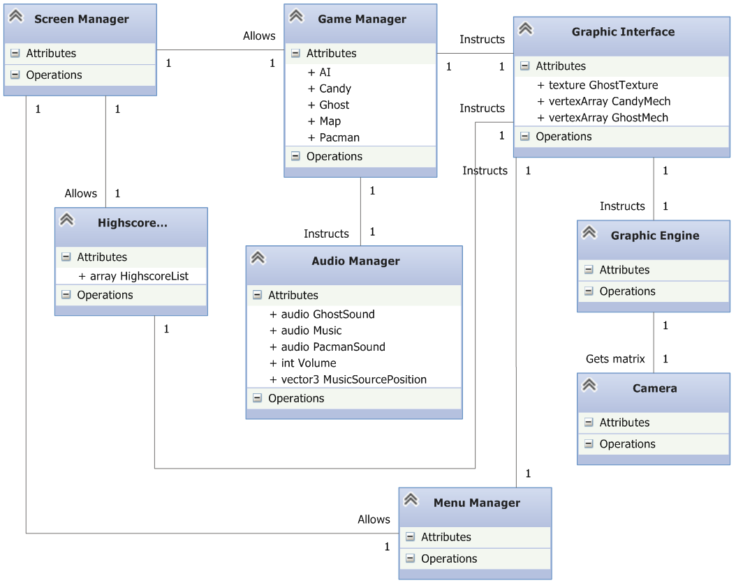

# Key Game Logic Concepts

This is an explanatory text detailing the key parts of our game logic engine.

## Maps

Maps are built using simple height map techniques. A .raw file is loaded from which a two-dimensional array is built with the values from the .raw files. From this map, the values are used to generate the different objects in the world. For instance, one specific value means a spawn point for a ghost and another means the location of a power up.   
 The map is also used to generate the 3D vertices. Any value above zero should be interpreted as a vertex composing the world on which Pacman can move. Zero-values compose the pits which Pacman risks falling into.  
 Collision detection also makes use of the map.  
  
AI  
The AI uses Dijkstra's algorithm[1] for path finding. The ghosts will get an updated path every 5-10 seconds. This makes the ghost aim for a spot that Pacman has already left making the path seem a bit random.  
When the ghost gets to his goal (the position where Pacman was) he will immediately get a new path. This makes it possible for the ghosts to catch Pacman.  
 We will also add a random generator making it possible for the ghost to head to a position where Pacman isn’t. This makes it harder for the ghosts to group up and making it available to play the game without dying really fast.

Collision Detection  
There are two different types of collisions: when Pacman walks into a pit and one where Pacman collides with an object (ghosts or candy).  
 The collision between Pacman and a pit will be determined by checking whether or not Pacmans position in the Y-axis (vertical) has a valid value. If the value for example is below a certain point pacman has fallen down into a pit.  
 The collision between Pacman and an object is determined by checking Pacmans position and the objects position. If they are in close enough proximity, it’s a collision  
  
Graphics  
The graphics engine is designed to be as independent as possible, to be able to be used for other projects and to be easily modified/upgraded. In order to use the engine, a graphics handler is used. The graphics handler is more specific for the game, containing game-specific shaders and vertex buffer calculations.   
 To summarize: the handler calculates the vertex buffer and the uniform valuables then sends it to the engine, which simply binds any buffer or uniform it receives. The camera works similarly.

# Class Diagram

This is the class diagram, split into two components for the purpose of lucidity. The two components (graphics and game logic) are also, by design, split into two components as independent of one another as possible.

## Game Logic Diagram

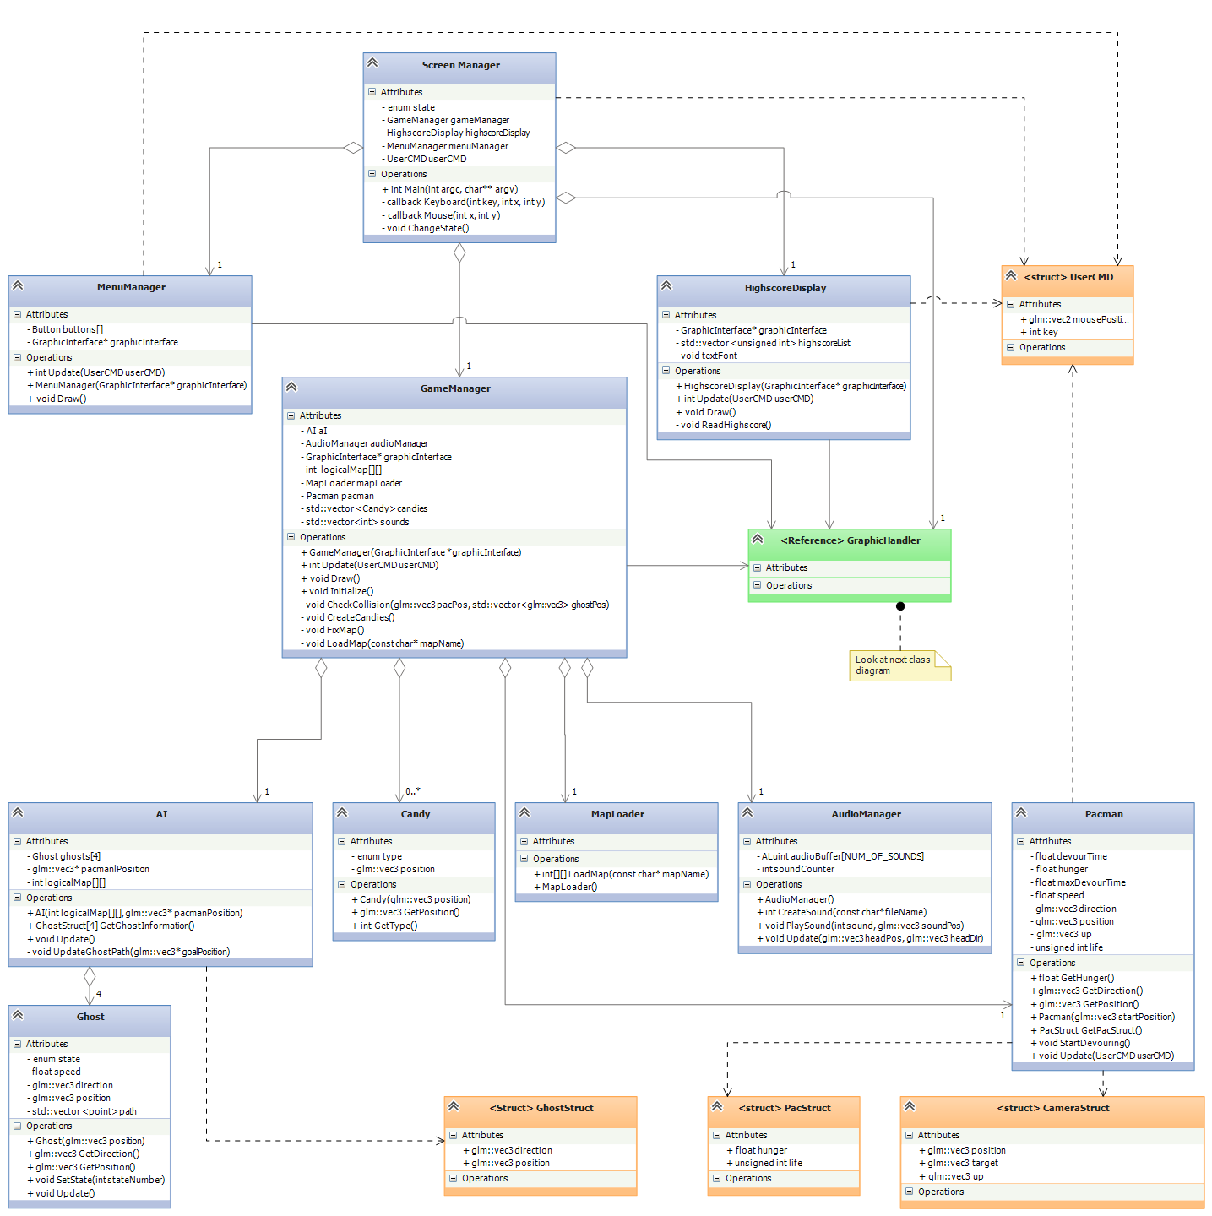

# Work Breakdown Structure

|  |  |  |  |  |  |  |
| --- | --- | --- | --- | --- | --- | --- |
| **Task** | **Start Date** | **Duration(days)** | **End Date** | **Est. Time(h)** | **Act. Time(h)** | **Act. Time/ Est. Time(%)** |
| Gameplay Design (1) | 20-jan | 4 | 23-jan | 2 | 2 | 100,00% |
| Achitecture/Design (1) | 21-jan | 3 | 23-jan | 58 | 58 | 100,00% |
| Wbs (1) | 23-jan | 1 | 23-jan | 3 | 7 | 233,33% |
| Writing L1 | 23-jan | 1 | 23-jan | 12 | 11 | 91,67% |
| **Total L1** | **20-jan** | 5 | **24-jan** | **75** | **78** | **104,00%** |
| R1 | 26-jan | 1 | 26-jan | 10 |  | 0,00% |
| Detailed L1 | 27-jan | 4 | 30-jan | 50 |  | 0,00% |
| Architecture/Design (2) | 27-jan | 4 | 30-jan | 5 |  | 0,00% |
| Gameplay Design (2) | 27-jan | 4 | 30-jan | 2 |  | 0,00% |
| Writing L2 | 31-jan | 1 | 31-jan | 10 |  | 0,00% |
| Changes in L1 | 31-jan | 1 | 31-jan | 5 |  | 0,00% |
| Wbs (2) | 31-jan | 1 | 31-jan | 2 |  | 0,00% |
| Total L2 | 27-jan | 5 | 31-jan | **84** | **0** | **0,00%** |
| R2 | 02-feb | 1 | 02-feb | 10 |  | 0,00% |
| Resources | 03-feb | 3 | 05-feb | 15 |  | 0,00% |
| Low-level Renderer | 03-feb | 4 | 06-feb | 40 |  | 0,00% |
| Gameplay foundations | 03-feb | 4 | 06-feb | 40 |  | 0,00% |
| Debugging | 07-feb | 1 | 07-feb | 10 |  | 0,00% |
| R3 | 09-feb | 1 | 09-feb | 10 |  | 0,00% |
| Audio | 07-feb | 7 | 13-feb | 50 |  | 0,00% |
| Visual Effects | 10-feb | 5 | 14-feb | 50 |  | 0,00% |
| R4 | 16-feb | 1 | 16-feb | 10 |  | 0,00% |
| Collision and Physics | 07-feb | 11 | 17-feb | 35 |  | 0,00% |
| Front End | 17-feb | 3 | 19-feb | 30 |  | 0,00% |
| Optimization | 18-feb | 2 | 19-feb | 20 |  | 0,00% |
| Documentation | 18-feb | 2 | 19-feb | 20 |  | 0,00% |
| Record Prototype | 20-feb | 2 | 21-feb | 20 |  | 0,00% |
| Total L3 | 03-feb | 19 | 21-feb | **360** | **0** | **0,00%** |
| R5 | 23-feb | 1 | 23-feb | 10 |  | 0,00% |
| Balancing | 24-feb | 2 | 25-feb | 20 |  | 0,00% |
| Modding | 24-feb | 3 | 26-feb | 30 |  | 0,00% |
| Update L1,L2 & L3 | 24-feb | 3 | 26-feb | 15 |  | 0,00% |
| Evaluations | 27-feb | 2 | 28-feb | 50 |  | 0,00% |
| R6 | 02-mar | 1 | 02-mar | 10 |  | 0,00% |
| Progress Report | 03-mar | 1 | 03-mar | 25 |  | 0,00% |
| Total L4 | 24-feb | 8 | 03-mar | **160** | **0** | **0,00%** |

# References

We have used the course main literature as a template for our architecture diagram. We have removed some of the content that they had since we found it unnecessary for this project. [2] For example we decided to not include skeletal animations on the basis that it is pointless in such a simple game as Pacman.

1. http://www.csc.kth.se/utbildning/kth/kurser/DD2458/popup11/dokument/graphs2.F6.09.pdf
2. Game Engine Architecture, Jason Gregory, 2009 Taylor and Francis group, p.29